PIZZA SALES SQL QUEIRES BY BUKOLA AMODU

Pizza Data

select * from pizza_sales

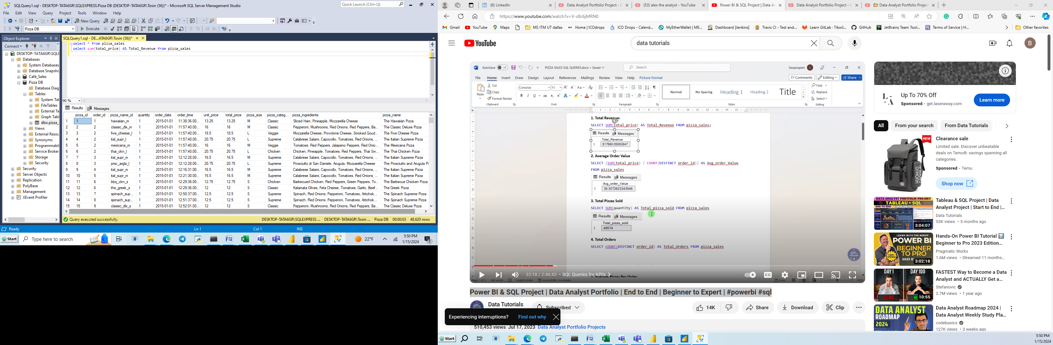

1. KPI REQUIREMENTS
2. Total Revenue:

select sum(total_price) AS Total_Revenue from pizza_sales

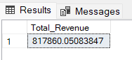

1. Average Order Value

select sum(total_price) / COUNT(DISTINCT order_id) AS Avg_order_Value from pizza_sales

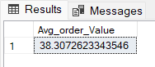

1. Total Pizza Sold

select sum(quantity) AS Total_Pizza_Sold from pizza_sales

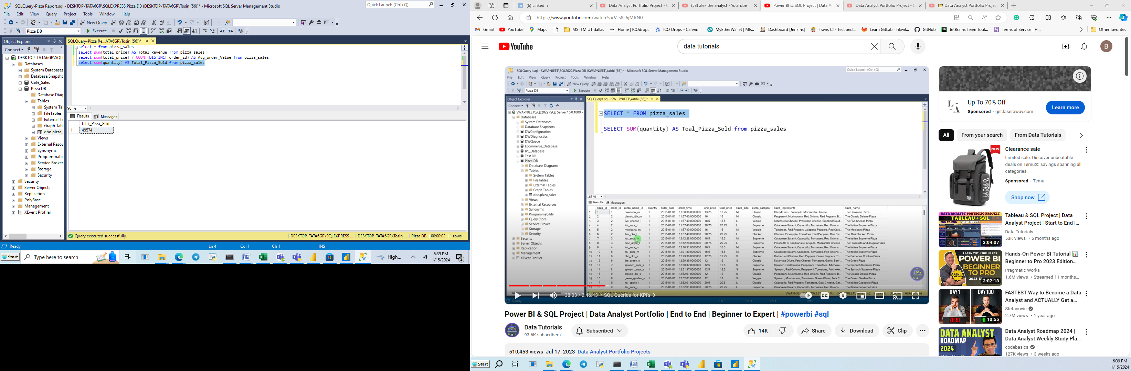

1. Total Orders

select COUNT(DISTINCT order_id) AS Total_Orders from pizza_sales

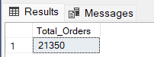

1. Average Pizza per Order

Without decimal

select sum(quantity) / COUNT(DISTINCT order_id) AS Avg_Pizza_per_order from pizza_sales

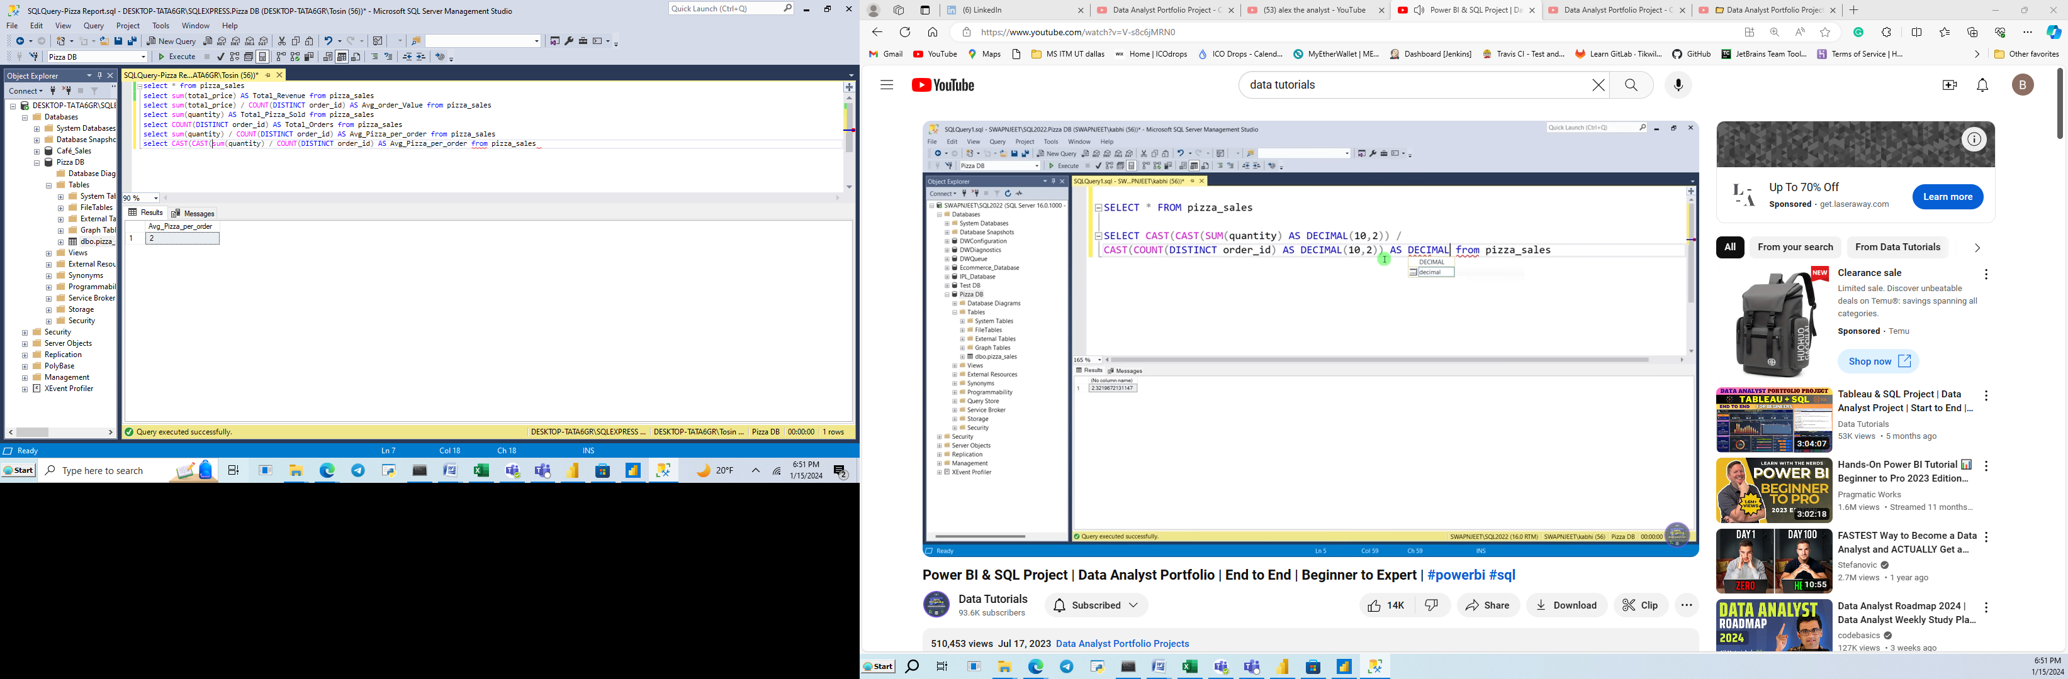

5b. With decimal which is what we will use for the Average Pizza per Order in our Power BI

Note we use “CAST” to cast the decimal as we desire as shown below:

select CAST(CAST(sum(quantity) AS DECIMAL(10,2)) / CAST(COUNT(DISTINCT order_id) AS DECIMAL(10,2)) AS DECIMAL(10,2)) AS Avg_Pizza_per_order from pizza_sales

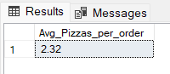

1. CHART REQUIREMENTS
2. **Daily Trend for Total Orders**

select DATENAME(DW, order_date) as order_day, COUNT(DISTINCT order_id) AS Total_orders

from pizza_sales

GROUP BY DATENAME(DW, order_date)

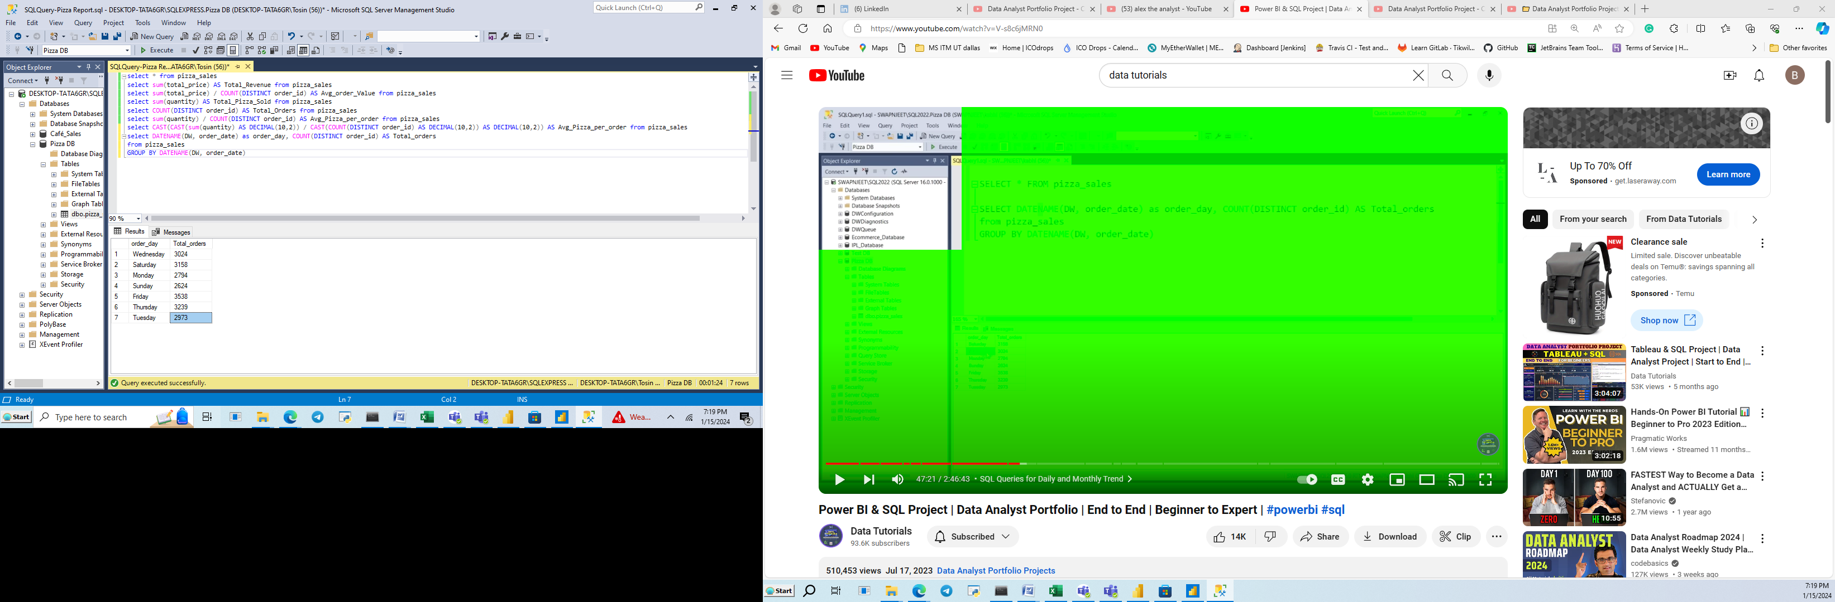

1. **Monthly Trend for Total Orders**

select DATENAME(MONTH, order_date) as Month_Name, COUNT(DISTINCT order_id) AS Total_orders from pizza_sales GROUP BY DATENAME(MONTH, order_date) ORDER BY (Total_orders)

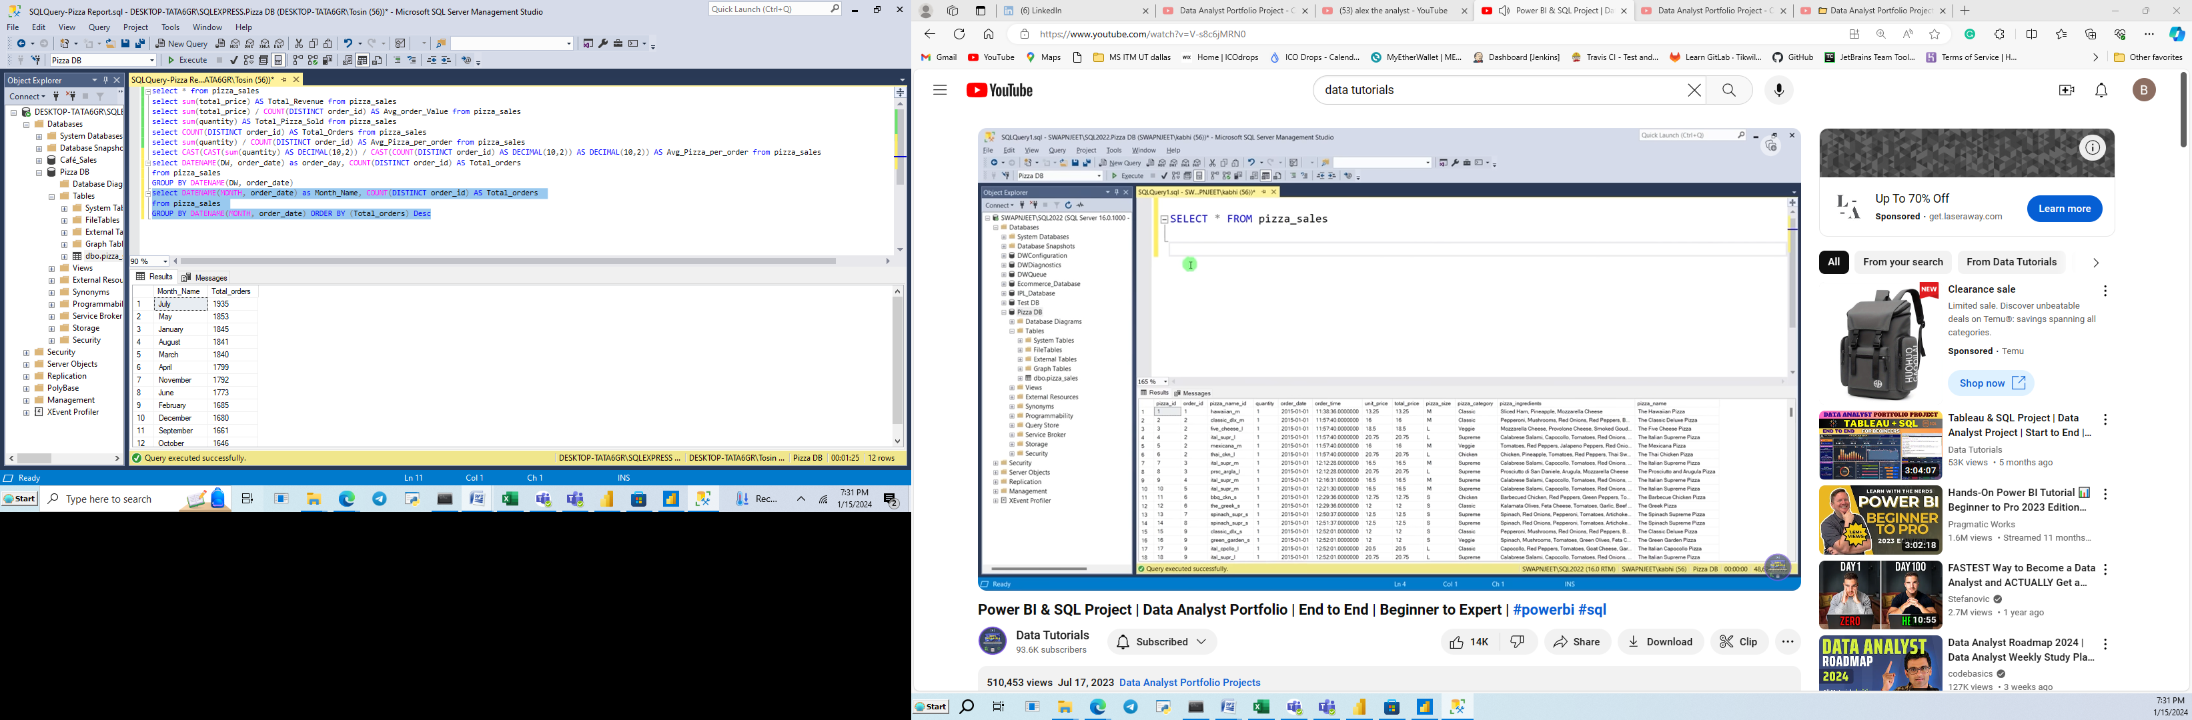

1. **Percentage of Sales by Pizza Category**

select pizza_category, sum(total_price) * 100 / (select sum(total_price) from pizza_sales) AS Percent_Sales

from pizza_sales GROUP BY pizza_category

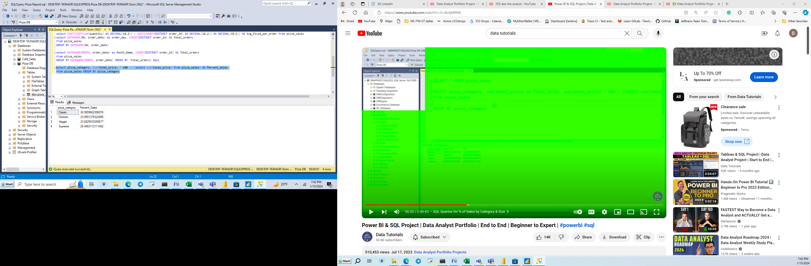

If we want to see the total sales in amount for each category then we have:

NOTE: Total Sales is Total revenue

select pizza_category, CAST(sum(total_price) AS DECIMAL(10,2)) AS Total_sales, CAST(sum(total_price) * 100 / (select sum(total_price) from pizza_sales) AS DECIMAL(10,2)) AS Percent_Sales

from pizza_sales GROUP BY pizza_category

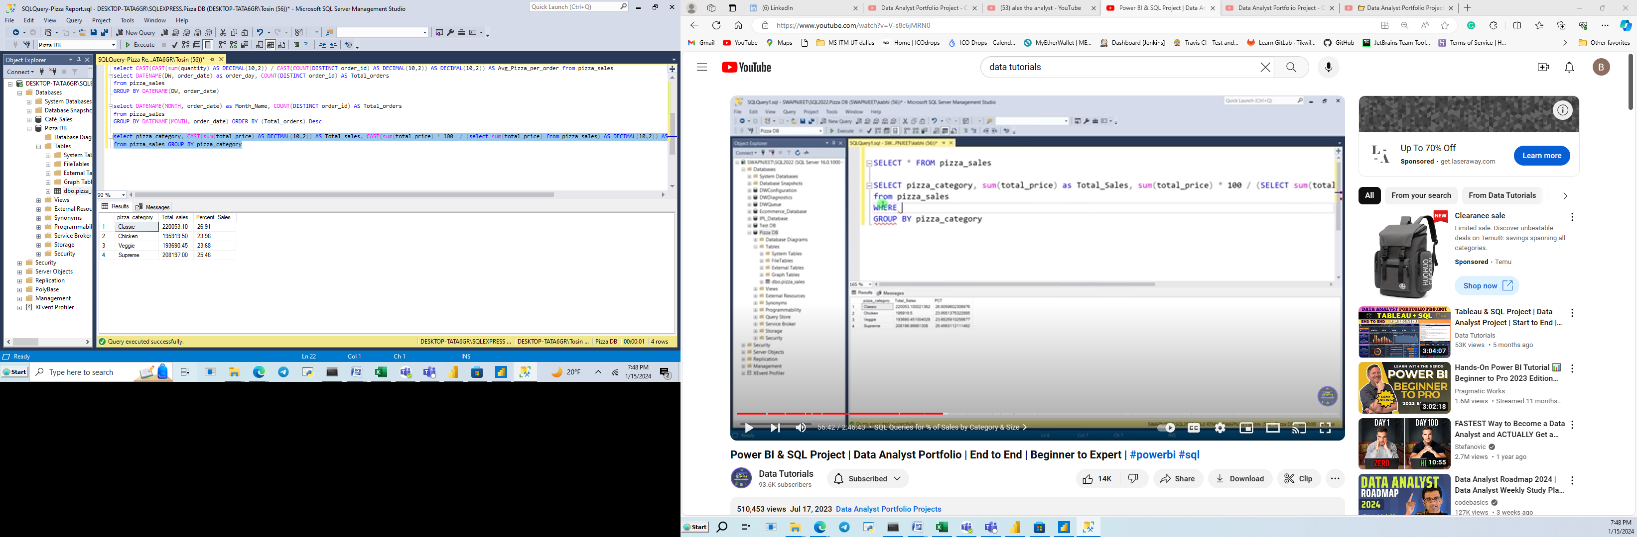

If we want Percentage of Sales by Pizza category for the month of January only, then we use WHERE function as well as shown below. Note that WHERE function will be applied to sub-query too as shown for this sub-query ‘(select sum(total_price) from pizza_sales WHERE MONTH(order_date) = 1)’

**Percentage of Sales by Pizza Category for the month of January**

select pizza_category, CAST(sum(total_price) AS DECIMAL(10,2)) AS Total_sales, CAST(sum(total_price) * 100 / (select sum(total_price) from pizza_sales WHERE MONTH(order_date) = 1) AS DECIMAL(10,2)) AS Percent_Sales

from pizza_sales

WHERE MONTH(order_date) = 1

GROUP BY pizza_category

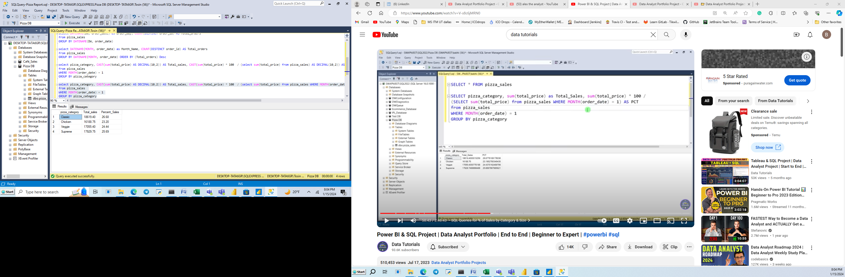

1. **Percentage of Sales by Pizza Size**

select pizza_size, CAST(sum(total_price) AS DECIMAL(10,2)) AS Total_sales, CAST(sum(total_price) * 100 / (select sum(total_price) from pizza_sales) AS DECIMAL(10,2)) AS Percent_Sales_per_Pizza_size from pizza_sales

GROUP BY pizza_size

ORDER BY Percent_Sales_per_Pizza_size DESC

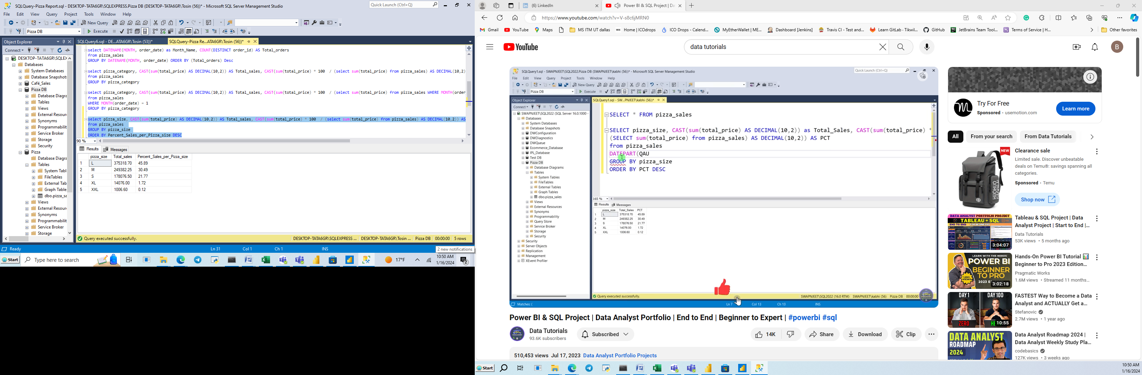

9b. Percentage of Sales by Pizza Size for first quarter

select pizza_size, CAST(sum(total_price) AS DECIMAL(10,2)) AS Total_sales, CAST(sum(total_price) * 100 / (select sum(total_price) from pizza_sales WHERE DATEPART(QUARTER, order_date)=1) AS DECIMAL(10,2)) AS Percent_Sales_per_Pizza_size

from pizza_sales

WHERE DATEPART(QUARTER, order_date)=1

GROUP BY pizza_size

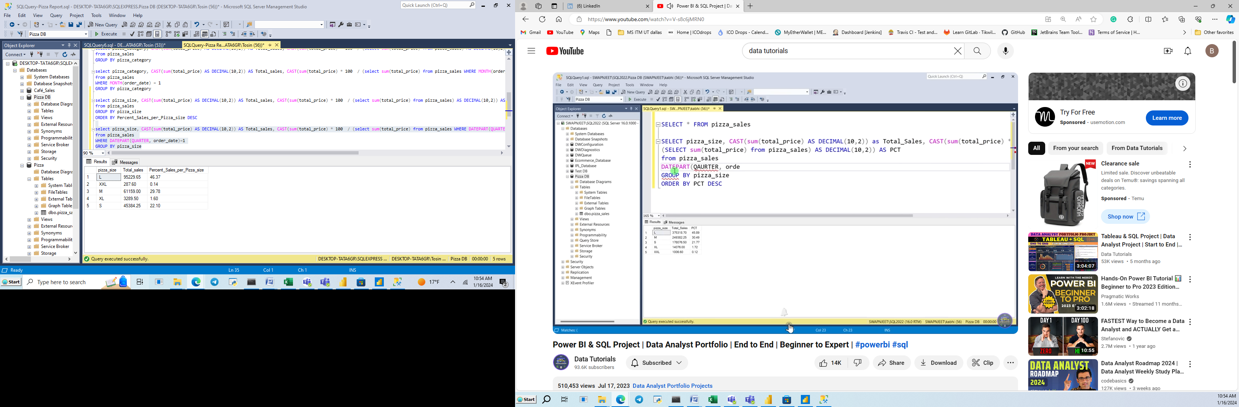

1. **Total Pizza Sold by Pizza Category**

SELECT pizza_category, SUM(quantity) as Total_Quantity_Sold

FROM pizza_sales

GROUP BY pizza_category

ORDER BY Total_Quantity_Sold DESC

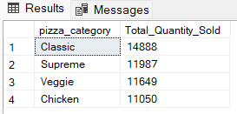

1. Top 5 Best Sellers by Revenue, Quantity and Total Orders

select TOP 5 pizza_name, sum(total_price) AS Total_Sales from pizza_sales

Group By pizza_name

Order by Total_Sales Desc

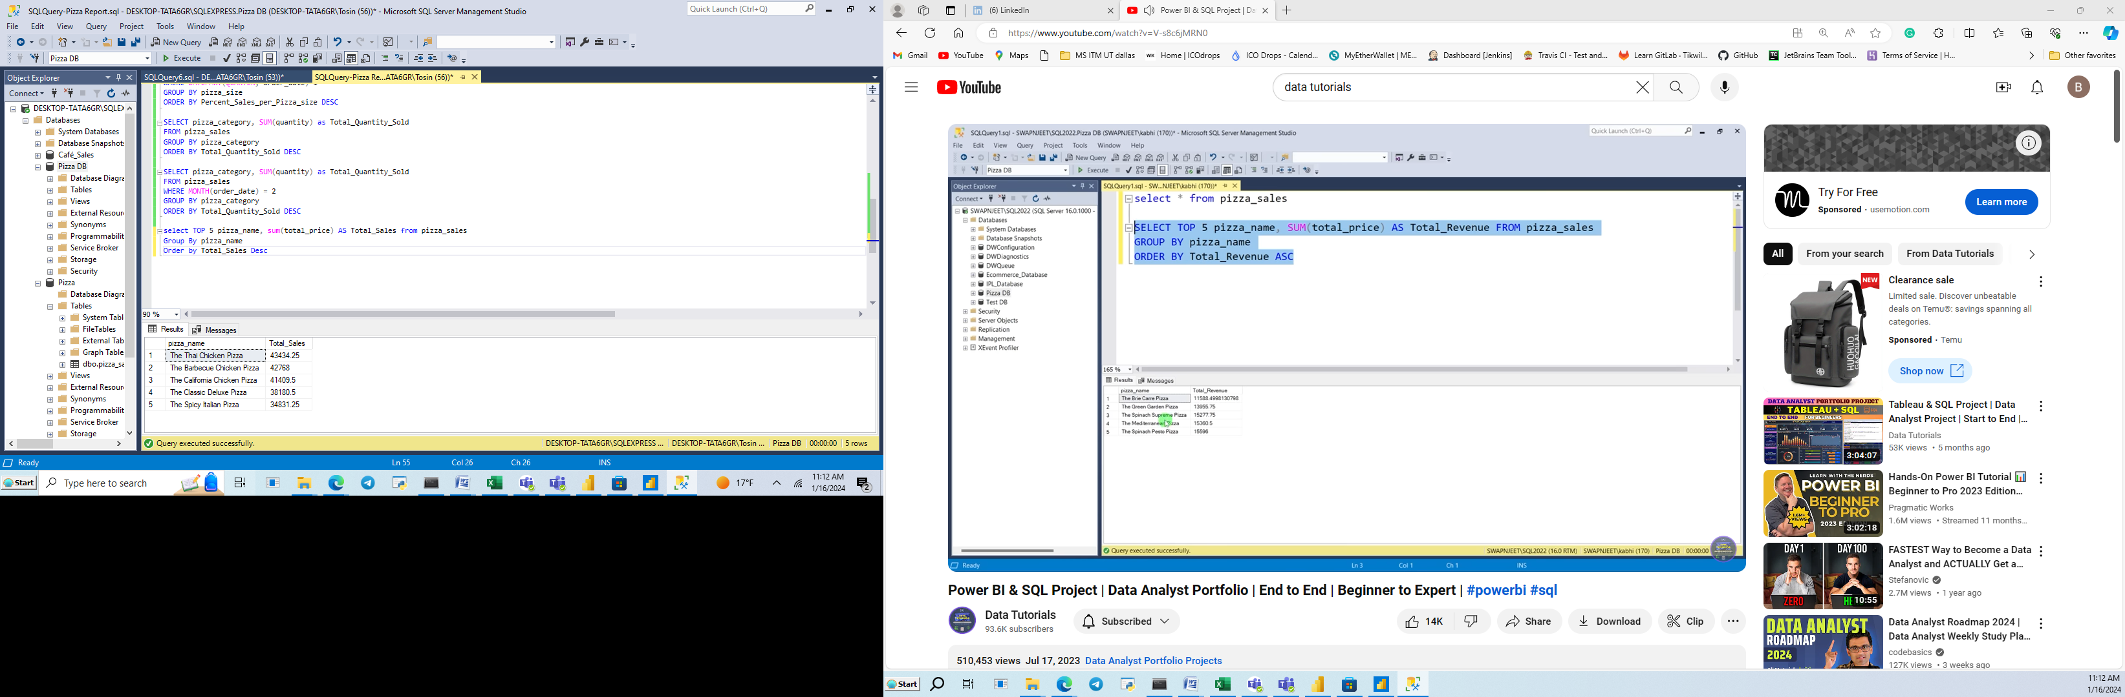

11b. Pizza Seller by Revenue

select pizza_name, sum(total_price) AS Total_Sales from pizza_sales

Group By pizza_name

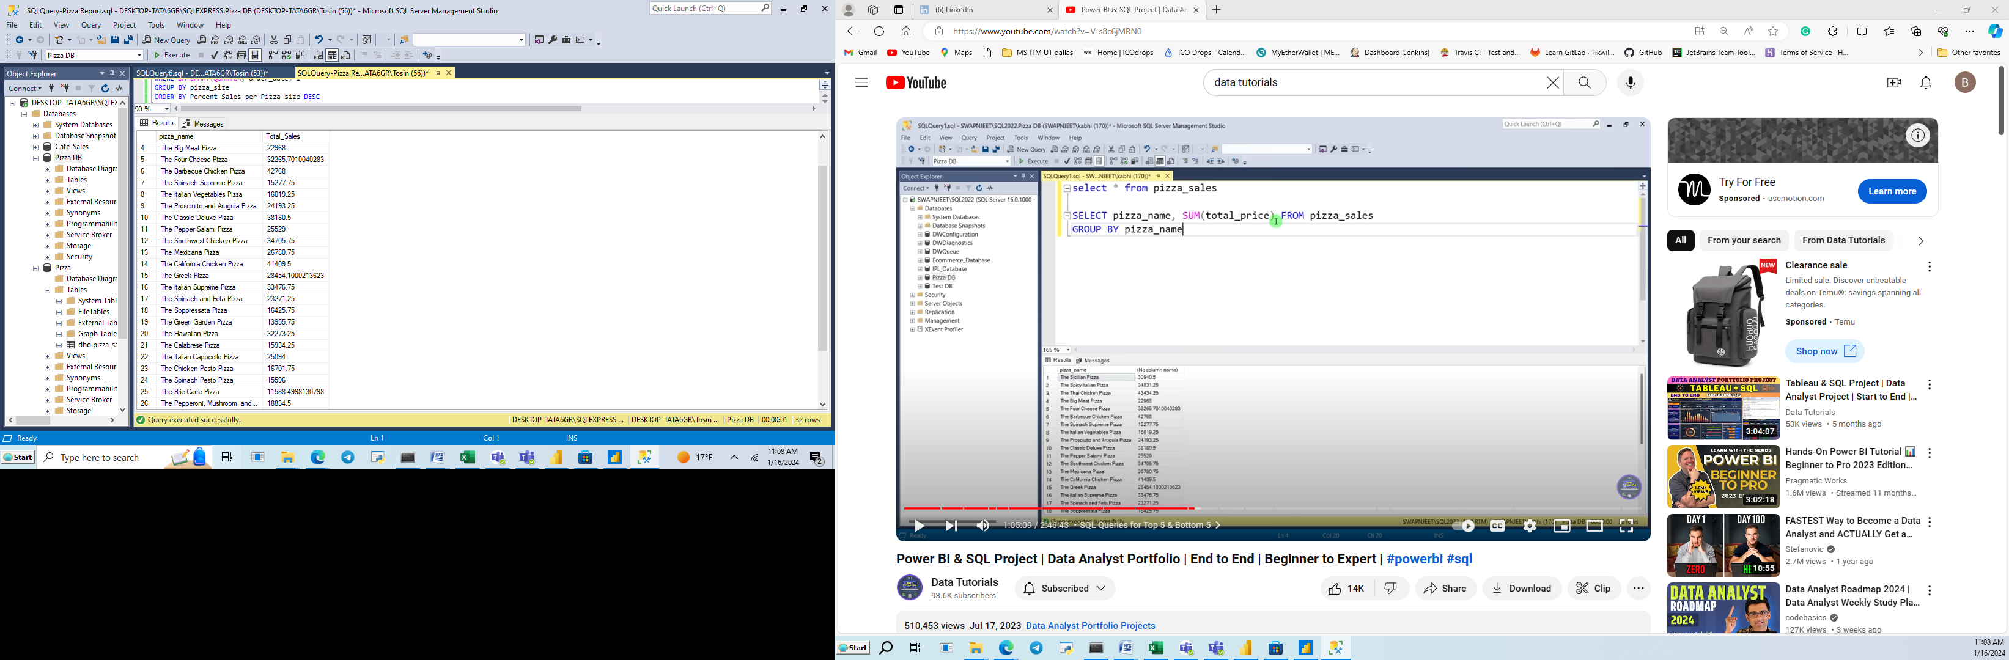

11c. Bottom 5 Sellers by Revenue

select TOP 5 pizza_name, sum(total_price) AS Total_Sales from pizza_sales

Group By pizza_name

Order by Total_Sales Asc

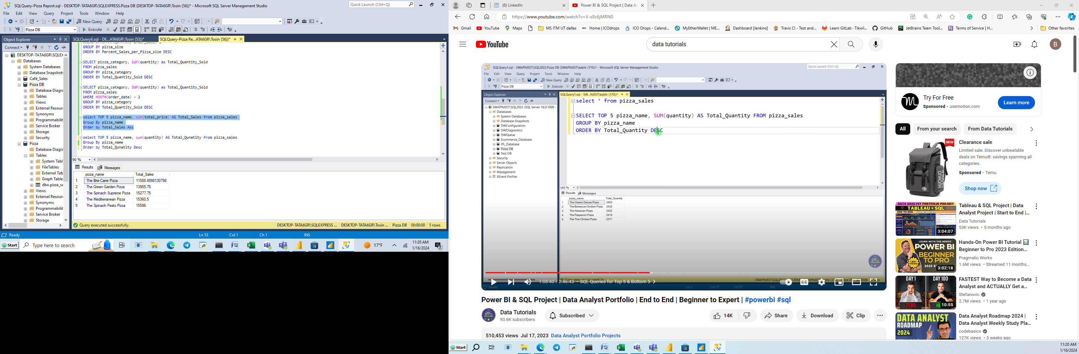

11d. Top 5 Pizza by Quantity

select TOP 5 pizza_name, sum(quantity) AS Total_Quantity from pizza_sales

Group By pizza_name

Order by Total_Quantity Desc

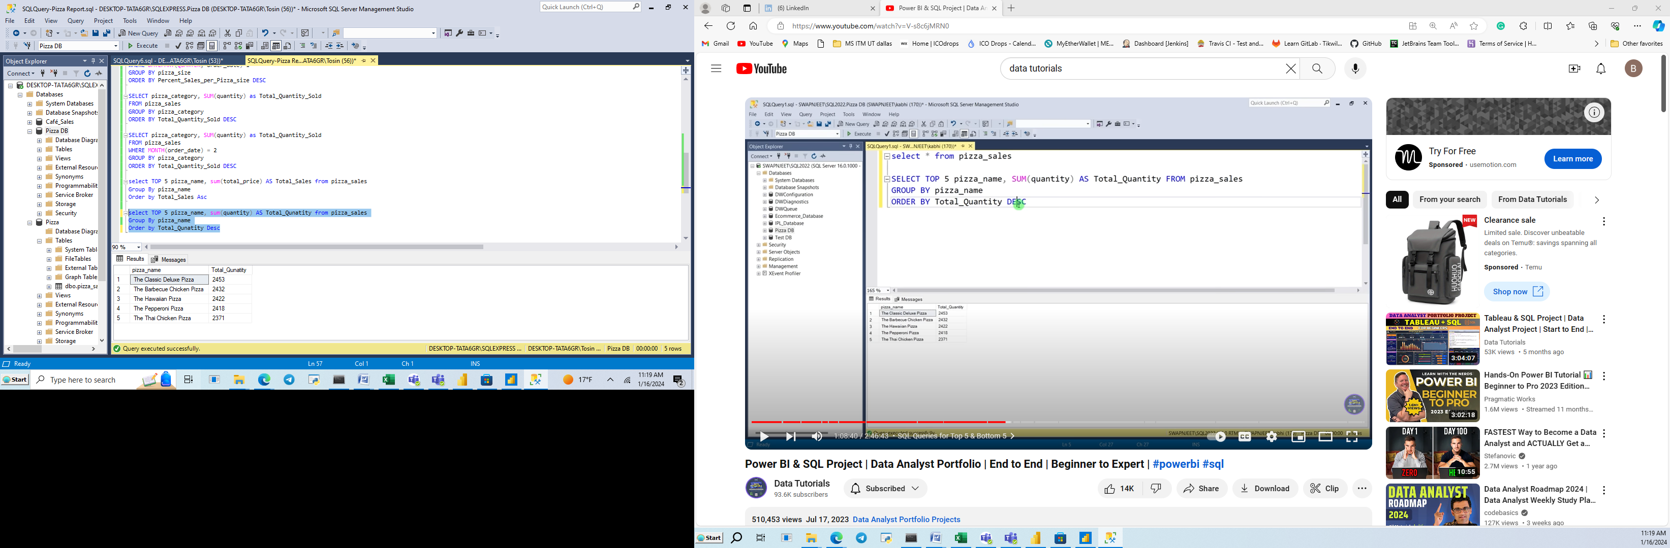

11e. Bottom 5 Pizza by Quantity

select TOP 5 pizza_name, sum(quantity) AS Total_Quantity from pizza_sales

Group By pizza_name

Order by Total_Quantity Asc

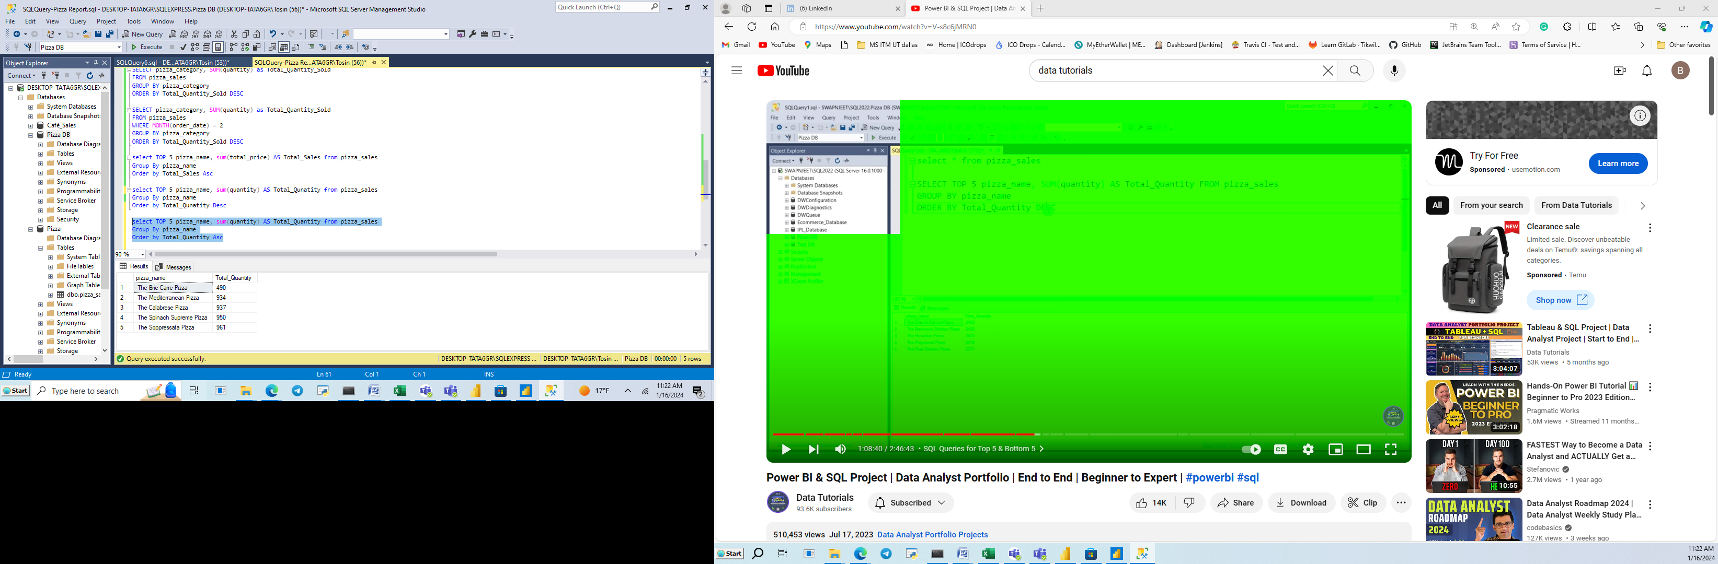

11f. Top 5 Pizza by Total Orders

select TOP 5 pizza_name, COUNT(DISTINCT order_id) AS Total_Orders from pizza_sales

Group By pizza_name

Order by Total_Orders Desc

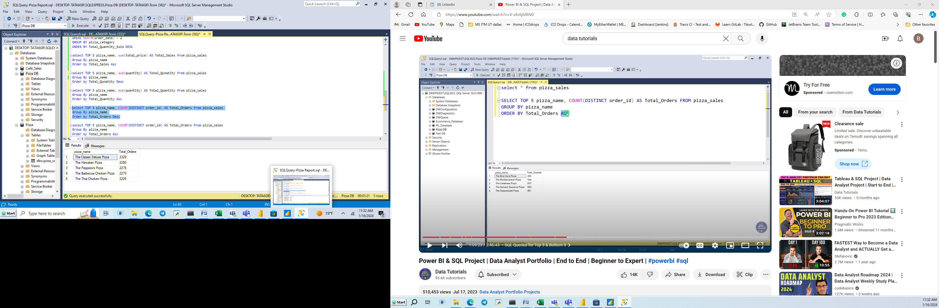

11g. Bottom 5 Pizza by Total Orders

select TOP 5 pizza_name, COUNT(DISTINCT order_id) AS Total_Orders from pizza_sales

Group By pizza_name

Order by Total_Orders Asc

Or

select TOP 5 pizza_name, COUNT(DISTINCT order_id) AS Total_Orders from pizza_sales

Group By pizza_name

